**Experiment Number – 4**

**Title - Program to add digits of a number using while loop**

**Theory-**

Python While Loop is used to execute a block of statements repeatedly until a given condition is satisfied. And when the condition becomes false, the line immediately after the loop in the program is executed.

Syntax:

**while condition:**

**# body of while loop**

Here,

1. A while loop evaluates the condition
2. If the condition evaluates to True, the code inside the while loop is executed.
3. condition is evaluated again.
4. This process continues until the condition is False.
5. When condition evaluates to False, the loop stops.

Flowchart of while loop-

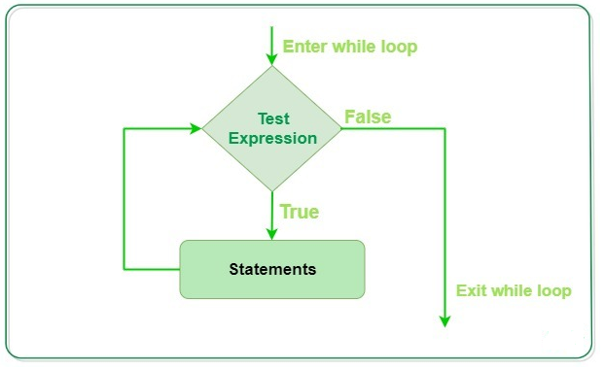

While loop falls under the category of **indefinite iteration**. Indefinite iteration means that the number of times the loop is executed isn’t specified explicitly in advance.

Statements represent all the statements indented by the same number of character spaces after a programming construct are considered to be part of a single block of code. Python uses indentation as its method of grouping statements. When a while loop is executed, expr is first evaluated in a Boolean context and if it is true, the loop body is executed. Then the expr is checked again, if it is still true then the body is executed again and this continues until the expression becomes false.

**Else Statement with While Loop**

Python supports to have an **else** statement associated with a loop statement.

* If the **else** statement is used with a **while** loop, the **else** statement is executed when the condition becomes false.

The following example illustrates the combination of an else statement with a while statement that prints a number as long as it is less than 5, otherwise else statement gets executed.

count = 0

while count < 5:

print count, " is less than 5"

count = count + 1

else:

print count, " is not less than 5"

Exercise-

1. Write a program to check whether the number is palindrome
2. Write a program to check whether the number is Armstrong number
3. Write a program to print first 10 items of Fibonacci series.
4. Write a program to count digits in a number.
5. Write a program to check whether the number is prime.